Course Name | ITD 2343 – Object Oriented Programming with C#
Instructor | Mark L. Pranger
Student Name | Eric Christensen
Due date | Oct 7, 2025
Grade | <grade earned here>
Grading Comments | <instructor comments here>

Week 5 – Programming Lab

Design of the Application UI:

Screen Shots needed for Submission:

Make a screen shot for each of the following points in the creation process
The form after all controls have been placed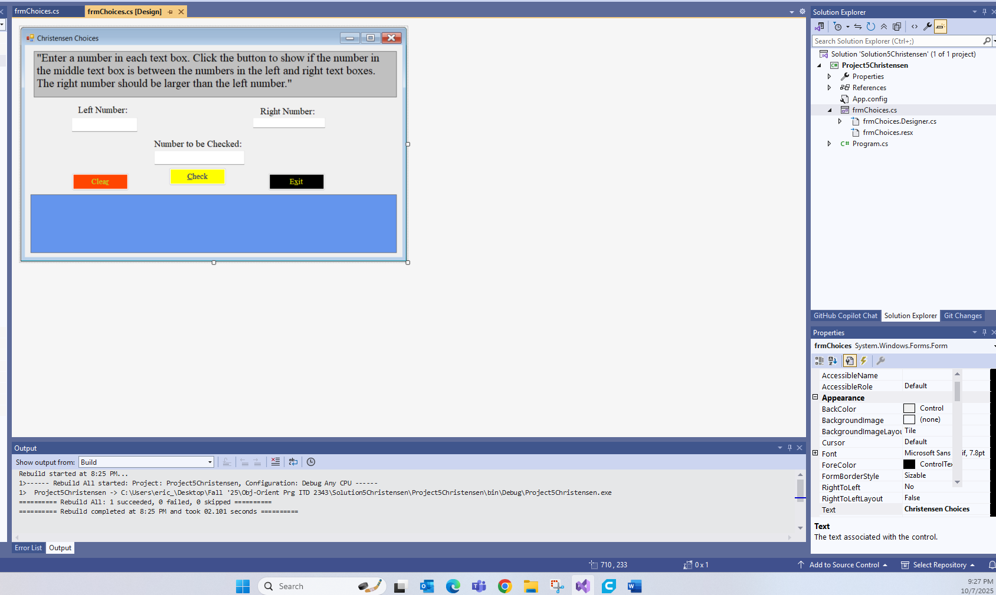
Show the code for the buttons in as few screen shots as possible
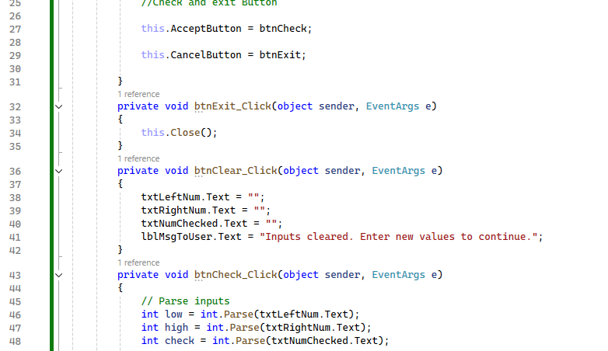
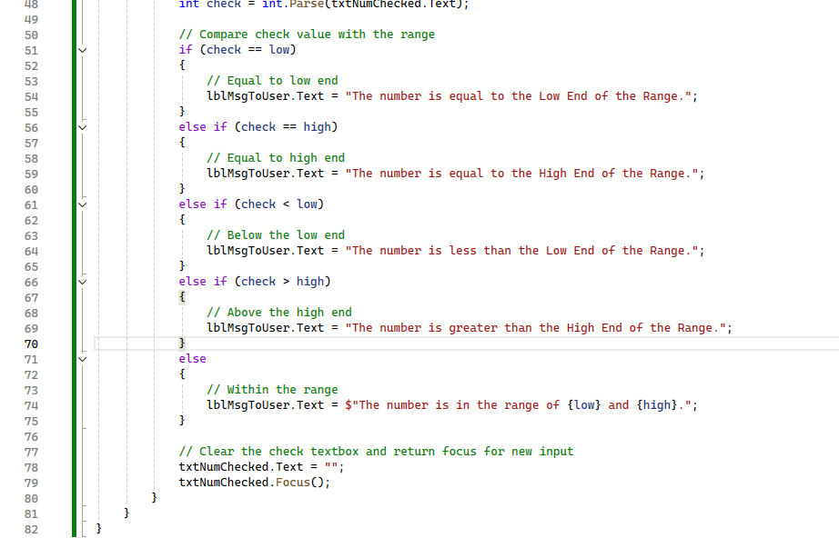

Highlight the button code in the screen shot(s)
Run the application in debug mode, screen shot the whole screen showing the form starting up
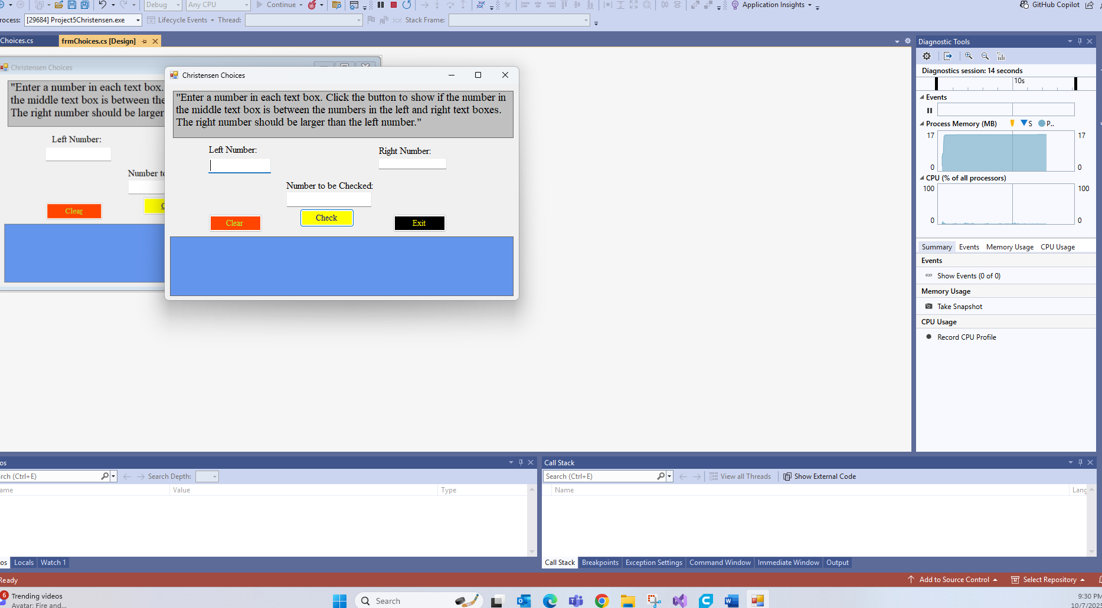

For the operations screen shots, show one screen shot depicting each of the following scenarios
Use 1000 for the high end of the range, -1000 as the low end of the range and 501 as the checked value
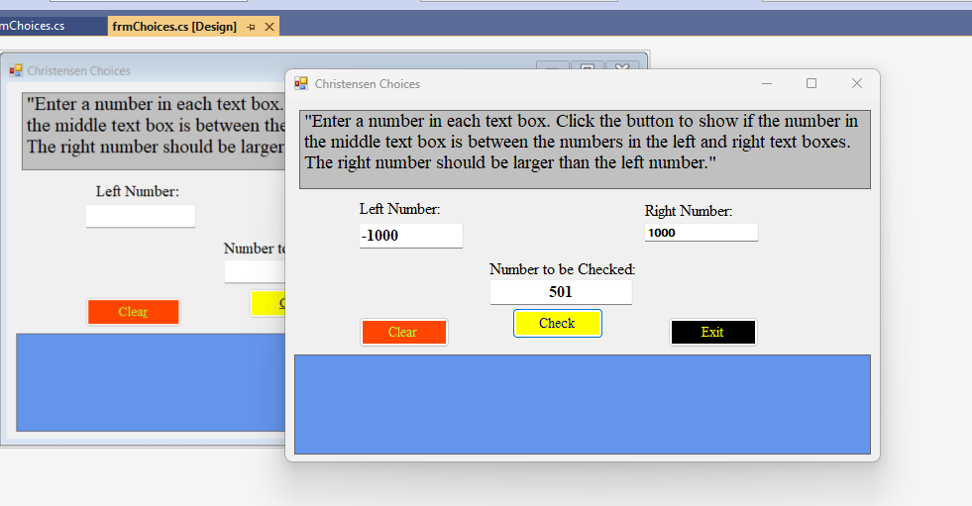

Enter in the following numbers for the Low and High and Checked value but nothing else, ie no clicking of the button

Show the form after you have clicked the button in the previous bullet item
Change the high end of the range number to 1000, click the check button and screen shot the results
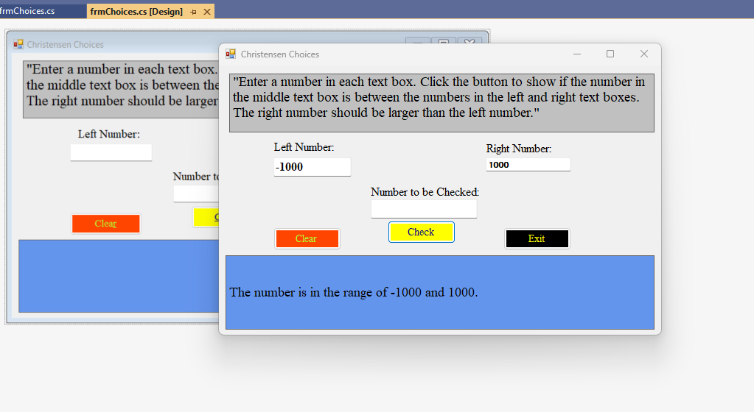

Change the checked value to -1000, click the check button and screen shot the results
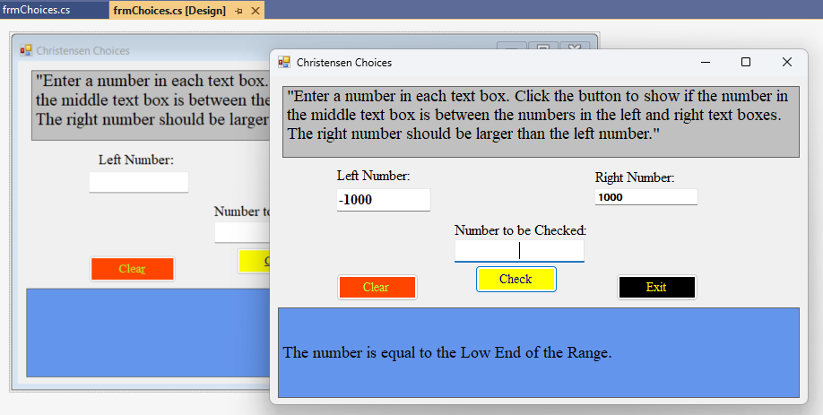

Change the checked value to 2021, click the check button and screen shot the results
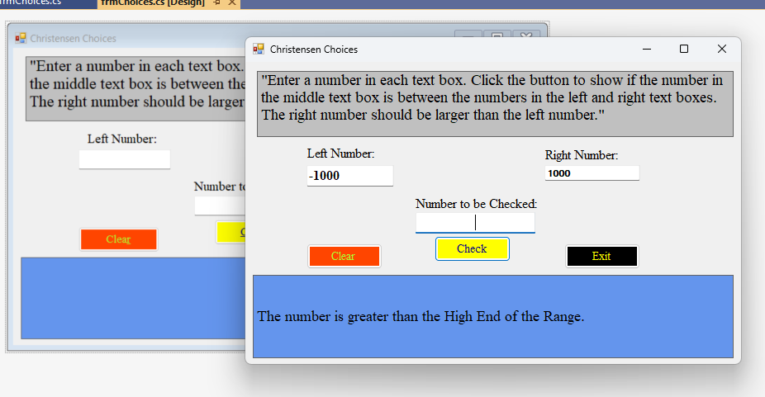

Check the checked value to -2021, click the check button and screen shot the results
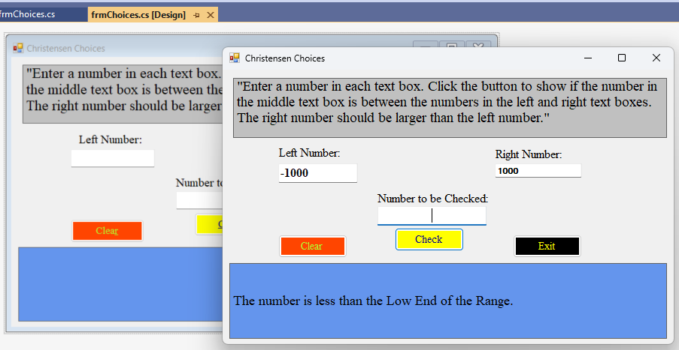

Change the Left Number, the Right Number and the Check Number to be the same number and then click the check button and screen shot the results
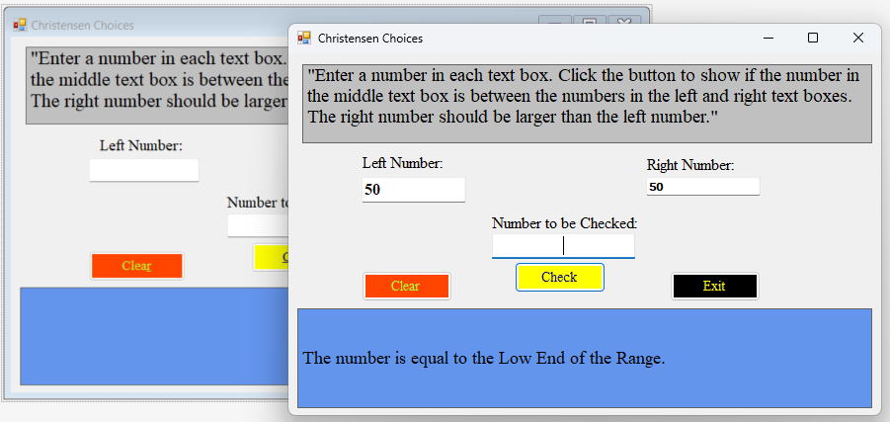

Click the clear button, screen shot the results.
